Title
Author

Table of Contents:
- Chapter One 2
  - Sub-Chapter One 2
  - Sub-Chapter Two 3
- Chapter Two 5
- Chapter Three 6
- Hit tab after a new line then insert the page number
  - To Insert a sub chapter just hit tab after you enter a new number 0

(Note, to make the dots go all the way across highlight the paragraph click format, paragraph, then goto the TABS tab and choose the leader you want).
Chapter 1
1.1.Sub Chapter Title

Information goes here about this chapter and sub chapter. Information that goes in this chapter should be divided and simplistic to understand. Words that are important if this is a text book should be made bold or italicized. To make text look and feel good it should be in a justified mode, this means that the beginning and end of the text will fit entirely withing the window, allowing a standard and tight format.

! | Warnings go in a table such as this, Warning when you use justified the text will no longer be completely natural; meaning spaces are made larger or smaller, allowing words to fill up the entire screen.

− | Information that should be taken note of is placed in a dialog box such as this.

 | Quotes go in a box such as this. When you are done press Tab and add a name.  --A Name Goes Here

 | Things to check at the end of each Chapter.  - What did you learn?  - Did you read everything?

1.2.Pictures
This image of Tux has a caption, boarder, and shadow.
This is the second installment of the chapters, inserting images is quite easy. To insert an image goto Insert>Picture>From File the picture will be inserted and all you do is drag and drop it to where you want it to be, the text will form around it. If you right click and press picture you can add a boarder in the boarder tab, and a shadow as seen to the right. You can also goto the wrap tab and choose how you want the image to respond to your text, falling in line with it, allowing the text to go along with it (done on the right), etc. There is one more cool feature that will help you and that is the caption feature, right click and press caption. Under the properties area you can choose a word such as Image this will add a piece of text such as Image 1-1 before your text you do not want this usually however it is sometimes handy so for now choose none. Captions should use the caption style, as shown in the next sub chapter.

1.4 Styles and Formatting

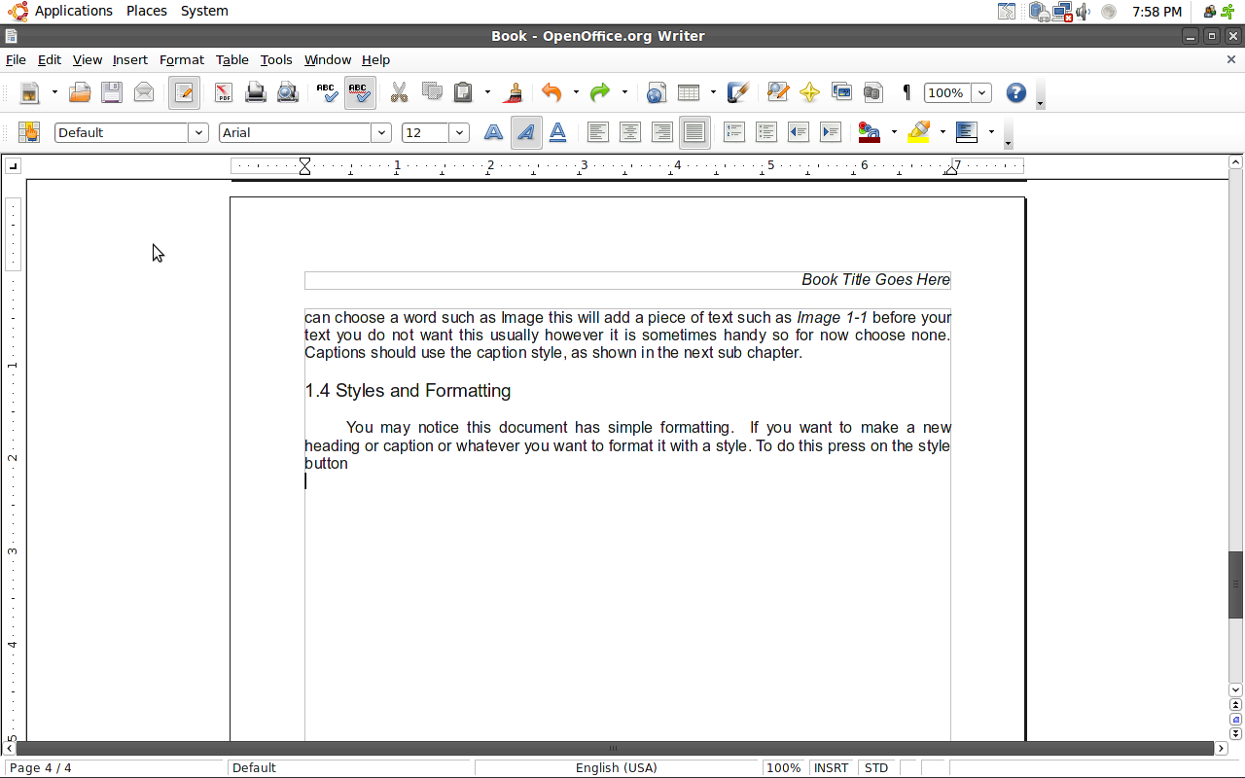
You may notice this document has simple formatting. If you want to make a new heading or caption or whatever you want to format it with a style. To do this press on the style button it is on your formatting tool-bar. To change your text highlight it and pull down the menu that says default right now and choose the proper heading.
- Default
  - Justified, Arial, 12pt.
- Chapter Title
  - Left, Arial, Bold, 20pt.
- Sub-Chapter
  - Left, Arial, 14pt.
- Caption
  - Arial, Italicized, 10pt., Centered

To change these press on the grid with the hand and the yellow, this will bring up a new frame in which you can right click and edit each one, the neat thing about styles is whenever you change a style all of the items styled like it will change too, allowing quick document changes.

− | To insert a new page, press [CTL]+[ENTER];
1.5 Changing Vital Information

To change the document owner, and such goto File>Properties.

Created by Joseph Lewis
09/03/23

