Baker Poster Presentation in Kenya Nairobi
```html

The Evolution of the Baker in Kenya Nairobi
A Poster Presentation Academic Document
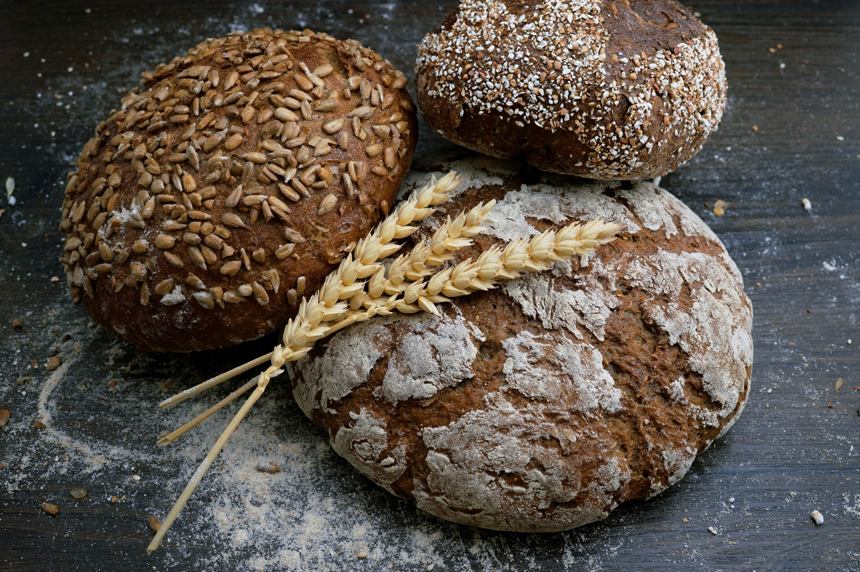

Introduction
The art of baking has transcended its humble origins to become a cornerstone of culinary arts globally. In the bustling city of Kenya Nairobi, the role and evolution of the 'baker' have taken on unique characteristics influenced by local traditions, economic factors, and global trends. This poster presentation aims to explore how bakers in Kenya Nairobi contribute significantly to both traditional culture and modern gastronomic experiences.

Historical Context of Baking in Kenya
Baking, as known today, was introduced during the colonial period but has evolved distinctly within the Kenyan context. Early baking techniques were primarily European-inspired but gradually adapted to incorporate local flavors and ingredients. Today's bakers in Kenya Nairobi stand at this crossroads of heritage and innovation.

The Modern Baker in Kenya Nairobi
In contemporary settings, a 'baker' is no longer just an artisan who crafts bread but also innovates with recipes that blend Kenyan cultural elements with international baking trends. Bakers in Kenya Nairobi often use local produce such as cassava, sweet potatoes, and indigenous fruits to create unique baked goods that appeal to both locals and tourists.

Economic Impact
The contribution of bakers extends beyond culinary delight; they play a pivotal role in the local economy. The rise of artisanal bakeries in Kenya Nairobi has not only created employment opportunities but also supported local farmers by sourcing fresh ingredients. This symbiotic relationship between bakers and other sectors highlights the integral part 'bakers' play in sustaining community economies.

Cultural Integration
Baking serves as a medium for cultural expression. Bakers in Kenya Nairobi are increasingly integrating traditional Kenyan recipes into their repertoire, ensuring that cultural heritage is preserved and celebrated through the universal language of food. This fusion approach not only enriches the local culinary landscape but also enhances tourism by offering unique gastronomic experiences.

Challenges and Opportunities
Despite its growth, baking in Kenya Nairobi faces challenges such as access to quality ingredients, technology, and consistent power supply. However, these challenges present opportunities for innovation and development. Supportive policies from the government along with training initiatives can empower bakers to overcome these hurdles.

Sustainability Practices
Modern bakers in Kenya Nairobi are also focusing on sustainability, adopting eco-friendly practices such as reducing waste, using sustainable packaging, and supporting ethical sourcing. These efforts align with global trends towards responsible consumption and production.

Conclusion
The story of the 'baker' in Kenya Nairobi is one of transformation and resilience. As they continue to blend tradition with innovation, bakers are not only preserving cultural heritage but also shaping a dynamic culinary future. This poster presentation serves as a testament to their pivotal role in both culture and economy.
© 2023 Baker Academic Study Kenya Nairobi | All Rights Reserved
```

